

Biao Wang School Management System
Unit Code: BIT3208
Unit Name: Advanced Web Design and Development
Student Name: Kagochi Brian Kahora
Admission Number: BSCCS/2024/54776
Course: Computer science
Lecturer Name: Michael Nyoro
Technologies Used:
HTML, CSS, PHP, MySQL, XAMPP
GitHub/Portfolio Link: https://github.com/kahosh-dev/BIT-3208-ADVANCED-WEB-DESIGN-AND-DEVELOPMENT

Table of Contents
Table of Contents
WEEK 1: Local Environment Setup 3
- Installation and Testing of Local Development Environment
- Required Evidence
- Student Reflection
WEEK 2: Wireframes and GUI Design 6
- User Interface Planning and System Design
- Required Evidence
- Student Reflection
WEEK 3: JavaScript and PHP Basics 9
- Frontend Interaction and Backend Foundations
- Required Evidence
- Student Reflection
WEEK 4: Backend Development and Authentication 12
- Backend Processing and Authentication Systems
- Modern Backend Alternatives
- Student Reflection
WEEK 5: Database Integration and CRUD Operations 15
- Database-Driven Application Development
- Creating Databases
- Creating Tables
- CRUD Operations
- SQL Database Table Creation Script
- Student Reflection
References……………………………………………………………………………….18

WEEK 1: Local Environment Setup
Installation and Testing of Local Development Environment

Required Evidence
Fig 1: Installation of XAMPP on Windows
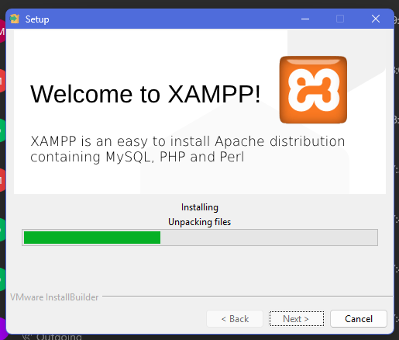
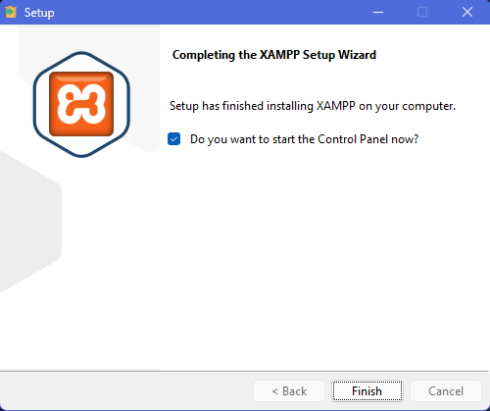

Fig 2: Apache and MySQL services running in XAMPP Control Panel
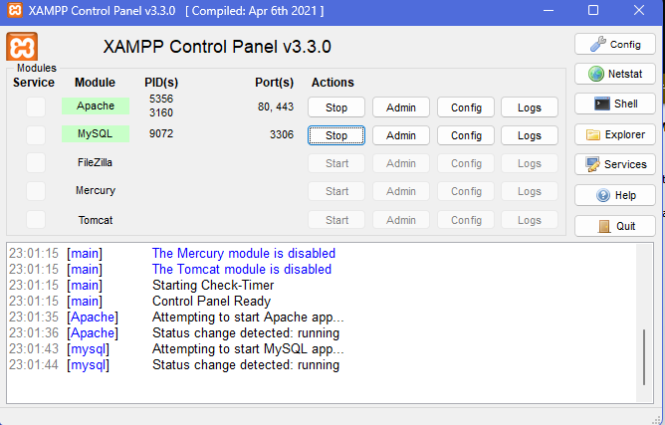

Fig 3: Localhost test page loading successfully in browser
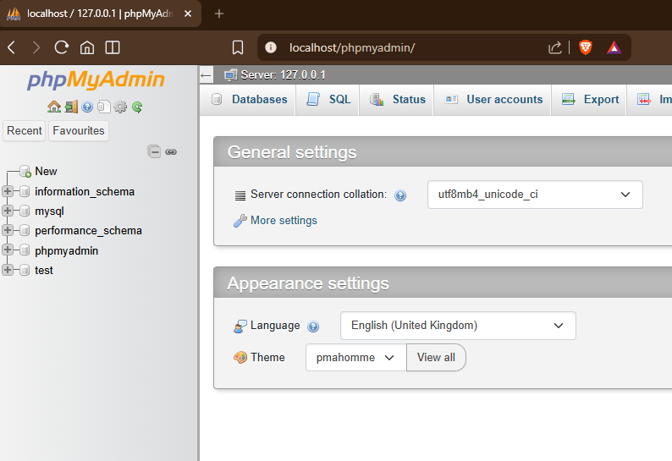

Fig 4: First PHP Hello World test page rendered in browser
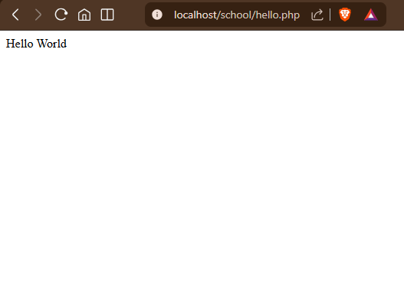
Fig 5: Successful database connection test to school_system_db using PHP mysqli_connect ()
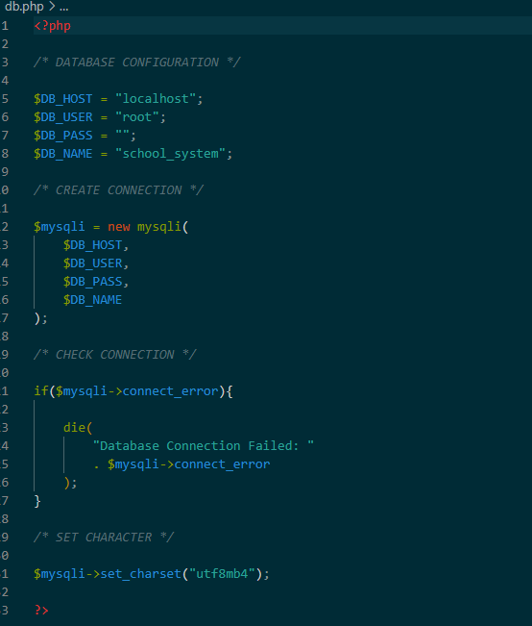

STUDENT REFLECTION
Week 1 I learned how to set up a local development environment XAMPP and Apache and MySQL services. I was able to successfully test localhost functionality, create my first PHP Hello World page, and connect PHP to MySQL databases. This week gave me a better understanding of server-side web development and localhost environments.

WEEK 2: Wireframes and GUI Design
User Interface Planning and System Design

Required Evidence
Fig 1: Hand-drawn wireframe of the Login page
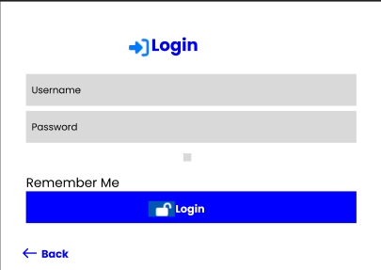
Fig 2: Dashboard layout design showing KPI cards and navigation
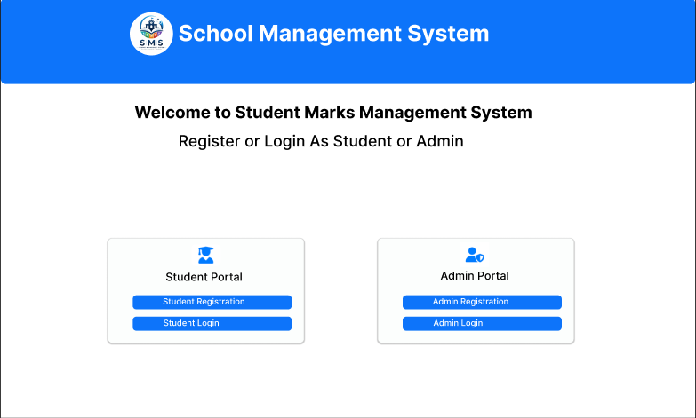

Fig 3: Mobile view mockup

Fig 4: Navigation Structure Plan for the School Management System.
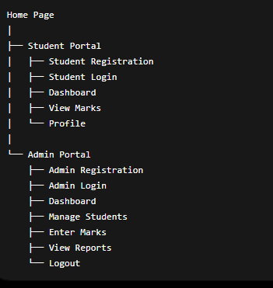

Fig 5: GUI prototype of the School Management System in Figma/Draw.io

Student reflection
Week 2: Worked on planning and designing interface for Student Management System. Before I implemented it, I created wireframes and dashboard layouts to get a sense of how the system would be structured. The design process taught me to organize user interfaces, plan navigation, colour themes and responsive layouts for desktop and mobile devices.

WEEK 3: JavaScript and PHP Basics
Frontend Interaction and Backend Foundations

Required Evidence
Fig 1: JavaScript form validation on the login page preventing empty submission
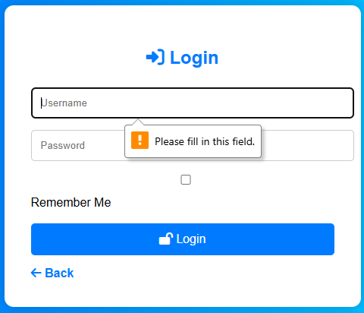
Fig 2: Password strength checker on the registration form
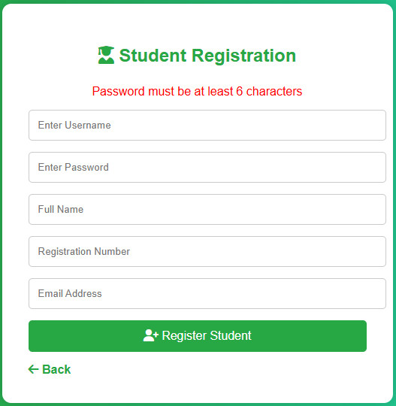

Fig 3: PHP database connection script (db.php) for MySQL

Fig 4: PHP Backend Functions and Database Processing Script
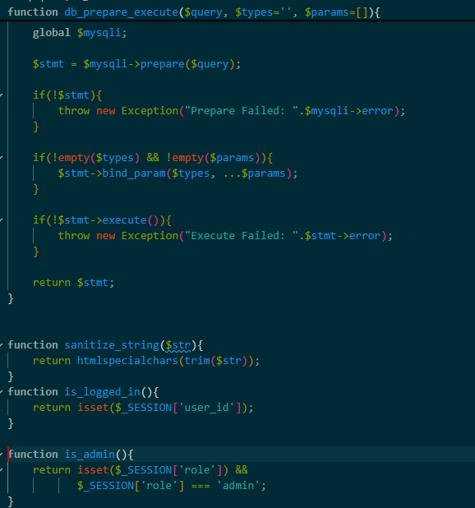
Fig 5: Dynamic user input handling — product search filtering results in real time
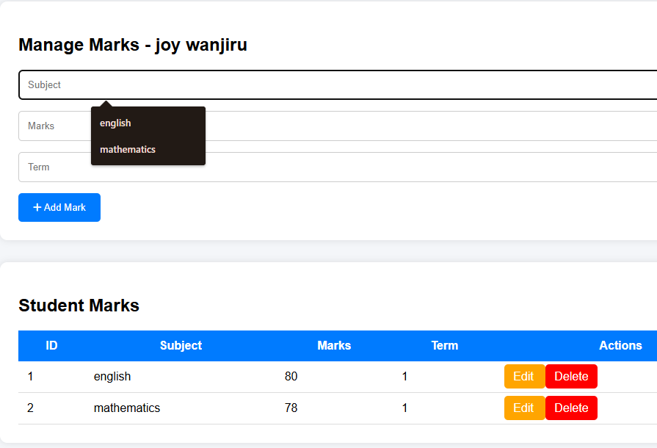

Fig 6: PHP Script Returning JSON Response from the Marks Table
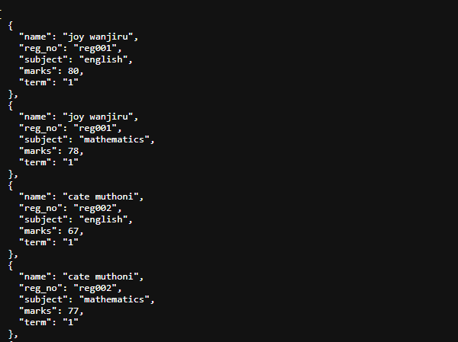

Student Reflection
Week 3 taught me how backend and frontend technologies work together in dynamic web applications. I also worked on Student Management System where I implemented form validation, password security, database connectivity, Json data & dynamic input. This week I learnt more about the PHP programming language, JavaScript validation and back-end processing concepts.

WEEK 4: Backend Development and Authentication
Backend Processing and Authentication Systems
Fig 1: Login Page Authentication Form
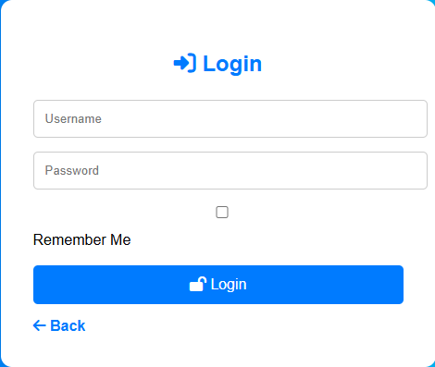
Fig 2: Session-Based Authentication Using PHP Sessions
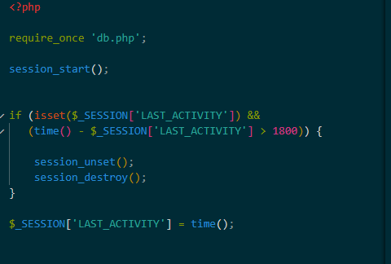

Fig 3: Admin Dashboard After Successful Login
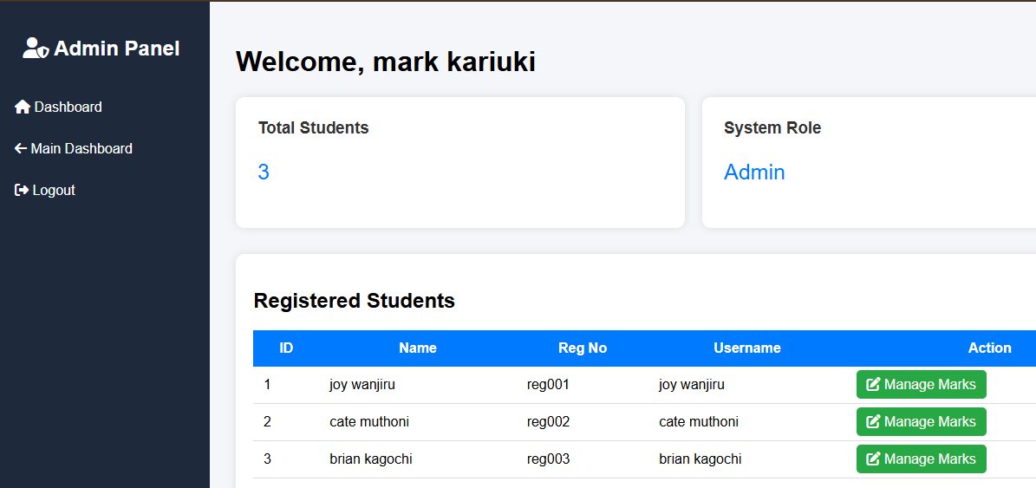

Fig 4: Student Dashboard After Successful Login


Fig 5: Role-Based Authentication Logic in PHP
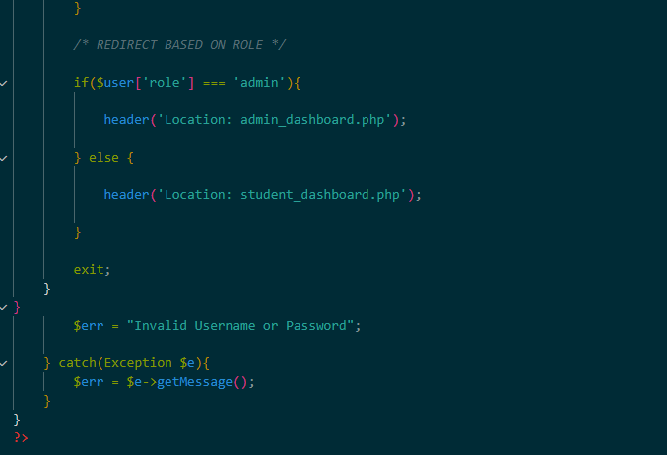
Fig6: Backend Folder Organization
Professional project structure
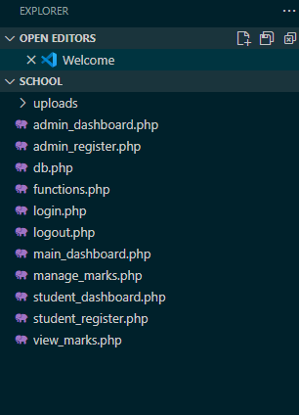

Reflection of a Student
In week 4 I learned how backend systems handle user authentication and sessions. Developed a role-based PHP and MySQL login system for students and administrator. This week helped me understand the session management, secure authentication, and backend processing workflows.

WEEK 5: Connecting the Database and CRUD
Database-Driven Application Development
Fig 1: Creating databases using phpMyAdmin.
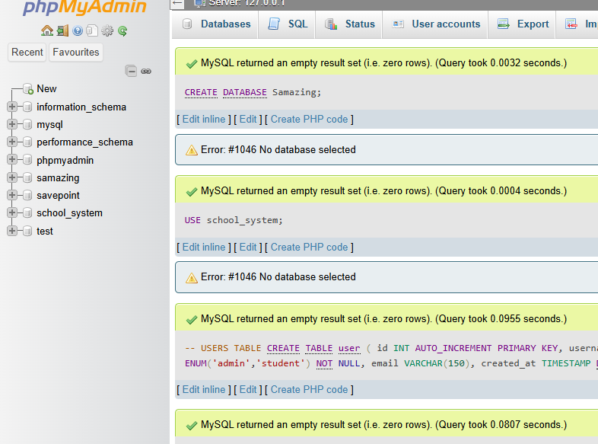
Fig 2:Creating tables inside the database.
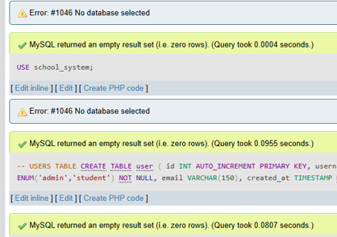
CRUD Operations
CRUD = Create, Read, Update, Delete
Fig 3: CREATE (Insert Record)
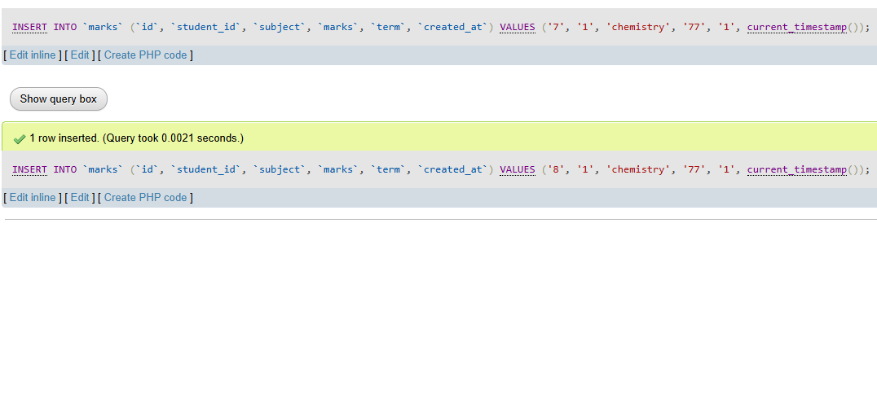
Fig 4: READ (View Records)
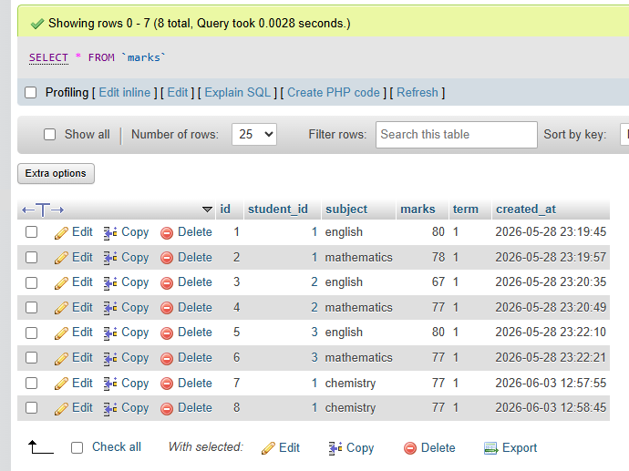
Fig 5: UPDATE (Edit Record)
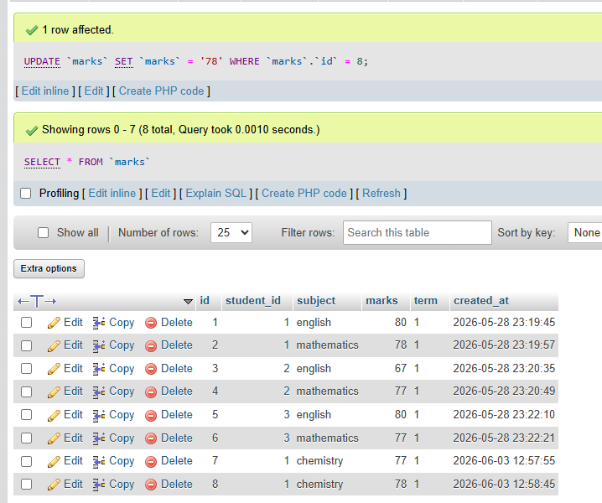
Fig 6: DELETE (Delete Record)
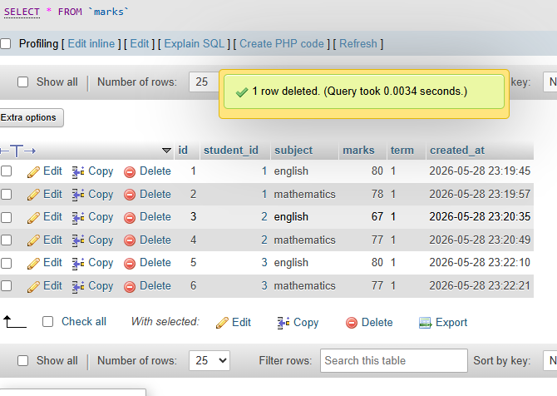

Fig 7: SQL Database Table Creation Script
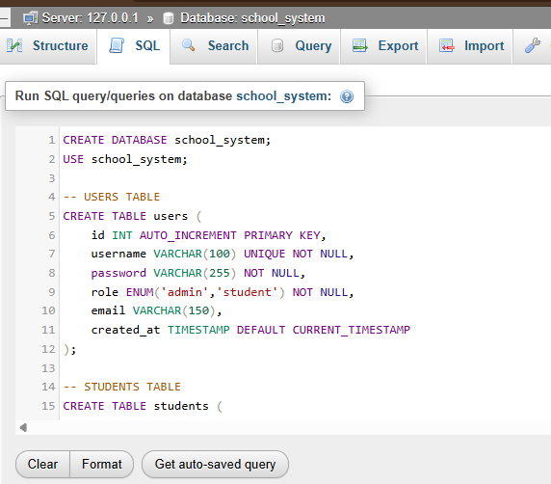
Reflection of a Student
Week 5 was about learning how to connect PHP applications to MySQL databases and how to do CRUD operations. I added a feature to manage marks, where an admin can dynamically add, edit, update, and delete records. This week's learning has increased my understanding of database driven systems and backend web application development.
References
- PHP Documentation – https://www.php.net
- MySQL Documentation – https://dev.mysql.com/doc
- XAMPP Documentation – https://www.apachefriends.org
- W3Schools – https://www.w3schools.com
- MDN Web Docs – https://developer.mozilla.org
- GitHub Documentation – https://docs.github.com

